Should be made in groups of max 6 students, handwritten, submitted on the next F2F session. Tardiness will cause a penalty of -5 per day. Distribute the homework within your group. Example: Ali will do number 1, Badu will do number 2, Charlie will do number 3, etc., and then staple your work together. Put your names and your sequential number on the first page. Do not put in my locker, it will be neglected.

- Find the extreme points if any: z=f(x,y)=2x³+xy²+5x²+y².
- Find the absolute max and min of f(x,y) = xy + y² on D if D is a closed rectangle region given by {(x,y): –1≤x≤1, –2≤y≤2}.
- Josephine wants to get from point A located in the sea to point Y located on a stretch of beach. P is the point on the beach nearest to A such that AP = 2 km and PY = 2 km. She does this by swimming in a straight line to a point Q located on the beach and then running to Y
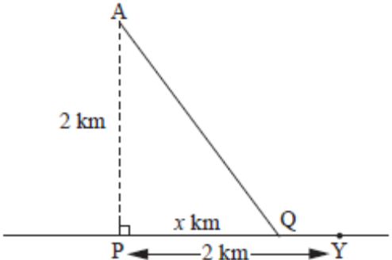 | (Hint: time = distance / speed)  When she swims, she covers 1 km in 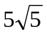 minutes. When she runs, she covers 1 km in 5 minutes
- If PQ = x km where 0 ≤ x ≤ 2, find an expression for the time T (minutes) taken by Jo to reach point Y.
- Show that 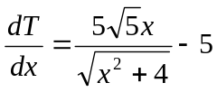 and using this find one extreme value of T
- Show that 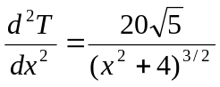 and hence show that the extreme value of T found above in part b is a minimum value (Hint: if f”(x) > 0 it is minimum and if f”(x ) < 0 it is maximum)
- The profit obtained by producing x units of product A and y units of product B is approximated by the model
P(x,y) = 8x + 10y - (0.001)(x² + xy + y²) - 10000. Find the max profit and the respective x and y.

